Lesson 8
Student’s name
Tutor’s name
Institution
Date

Lesson 8
- Why do men’s and women’s shirts button in different directions?
In the Victorian era, women’s buttons were made facing the left side to make it easier for their servants to dress them since the servants were mostly right handed whereas the men’s buttons were made facing the right because they mostly dressed themselves. This culture was carried on to date.
- When did Pablo Picasso live (birth and death dates)? When did Albert Einstein live (birth and death dates)? Is it even possible that they ever could have met in Paris??
Pablo Picasso was born in October 25th 1881 and died on April 8th 1973. Albert Einstein was born in March 14th 1879 and died in April 18th 1955.
Einstein travelled to Paris between 28th March and April 10th 1922 the two men met at a bar called Lapin Agile (Nimble Rabbit) in Paris.
- What does a Barrister’s table look like in an English Courtroom?
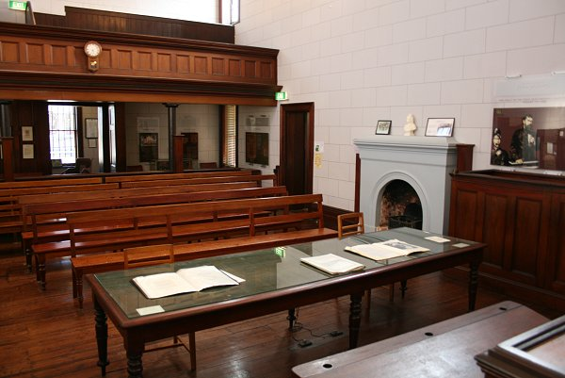
- What type of lighting is used the public areas of a subway station?

- Which leg did John Wilkes Booth break jumping down from the box after assassinating Lincoln? Which leg did he limp with?
John Wilkes broke his left leg after assassinating Lincoln and limped with his right leg.
- What is the recipe for Pecan Tassies? Can we make them? They have to be eaten on stage in front of the audience!
Ingredients
- 1½ cup of softened butter
- 3 ounces of softened cheese
- 1 cup of all- purpose flour
- ¾ cup brown sugar
- Dash salt
- 1 teaspoon vanilla extract
- 2/3 cup finely chopped pecans, divided
- 1 large egg
The directions to make them are;
- In a small bowl, beat butter and cream cheese until smooth; gradually beat in flour. Refrigerate, covered, 1 hour or until firm enough to roll.
- Preheat oven to 375°. Shape dough into 1-in. balls; press evenly onto bottoms and up sides of greased mini muffin cups.
- For filling, in a small bowl, mix egg, brown sugar, butter, vanilla and salt until blended. Stir in 1/3 cup pecans; spoon into pastries. Sprinkle with remaining pecans.
- Bake 15-20 minutes or until edges are golden and filling is puffed. Cool in pans 2 minutes. Remove to wire racks to cool.
Freeze option: Freeze cooled cookies, layered between waxed paper, in freezer containers. To use, thaw in covered containers.

- When in Houston can I find a size 13 women’s shoe (to fit a man’s foot)? Provide store, address and website if possible.
In Houston such shoes can be found in Pinto Ranch, 1717 Post Oak Blvd Houston, TX 77056 pintoranch.com
- How do i get an old- fashioned telephone (NOT a MOBILE PHONE) to ring on stage? Provide 2 options.
Option one; get a magneto out of an old wooden phone and have a stage hand cranjk it at the appropriate moment.
Option two; get an old- fashioned doorbell, with transformer and button from a hardware store and put the bell in or near the phone. Have a stagehand push the button at the appropriate moment and although the sound will not be authentic, it will work.
- How much would it cost to buy 8 matching baseball caps, baseball gloves, and baseball bats to dance with? Provide source and itemized list of costs. https://www.baseballsavings.com
1 Baseball cap – $8.95
1 Baseball glove – $45.95
1 Baseball bat - $27.95
Total for 8 matching caps, gloves and bats will be: $662.8

